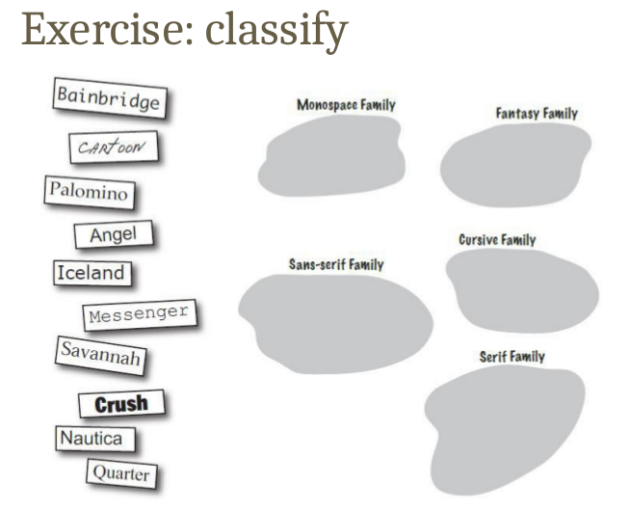
Monospace Family: Quarter, Savanahh
Fantasy Family: Bainbridge, Crush
Sans-serif Family: Iceland, Angel
Cursive Family: Cartoon
Serif Family: Nautica, Palomino

